**Notes 28/09/18**

**Narrative Game**

* Single player
* Branching narrative (3/4 endings)
* Story changes based on the choices the player makes
* Underlying themes of mental health
* 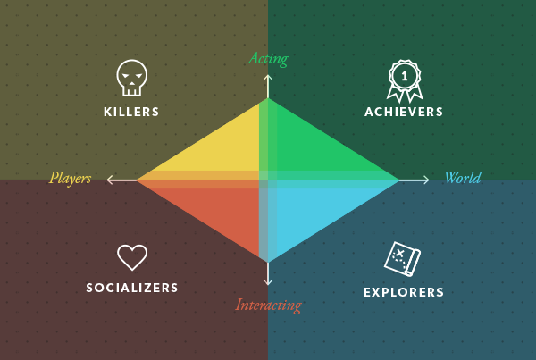Storybook art style

Target audience:

* Males and females – art style may appeal to females, but we also want to appeal to males because they are statistically less open about mental health
* Explorers (Bartle’s player types)

Types of fun (4 Keys 2 Fun):

* Serious fun – purposeful, changes how players think
* Easy fun – exploration, curiosity, creativity

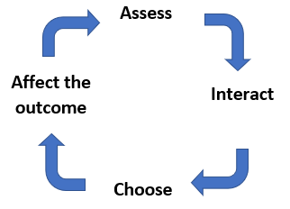Game loop: 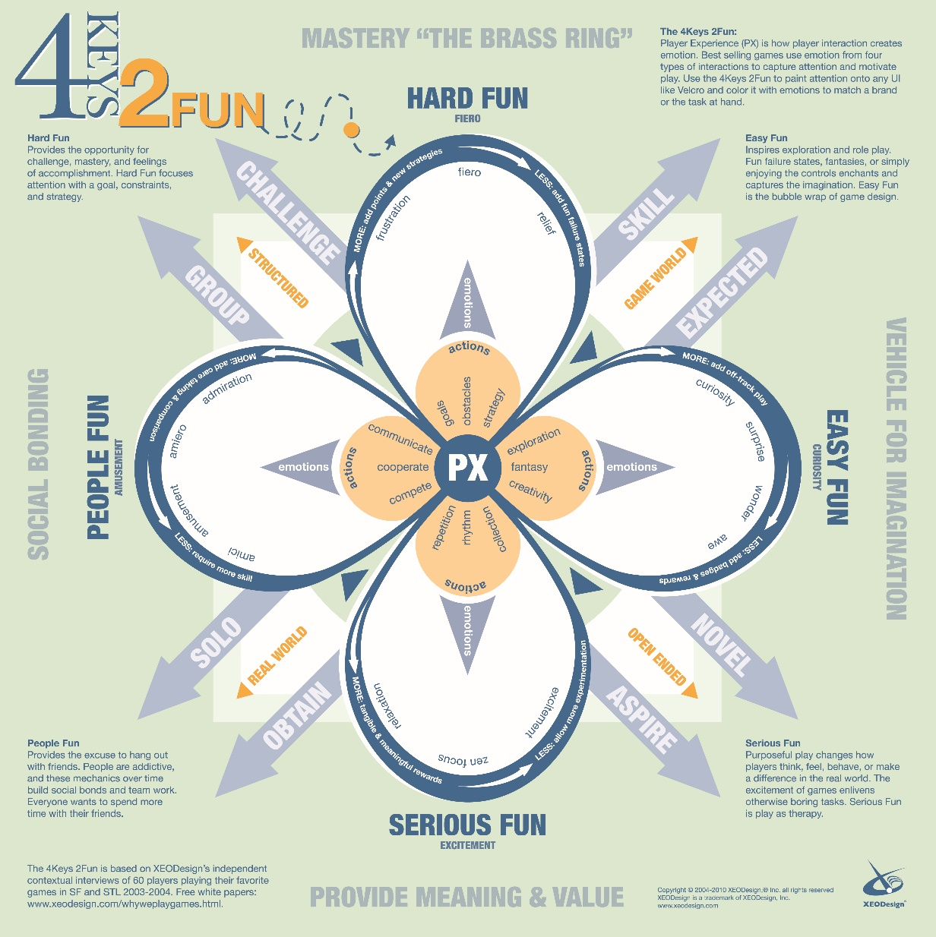

* Player assesses the situation
* Player may choose to interact with various things on the page
* Player makes a choice out of 3 different options
* The choices the player makes affect the progression of the story

**Zodiac Game**

* Single player
* The player has the ability to transform into different animals (based on the Chinese Zodiac)
* Each animal has different abilities which can be used in different situations depending on the player’s requirements
* Chinese shadow play/shadow puppetry art style to tie in with the theme

Target audience:

* Teenagers and young adults – the game wouldn’t suit casual gamers due to the complex mechanics

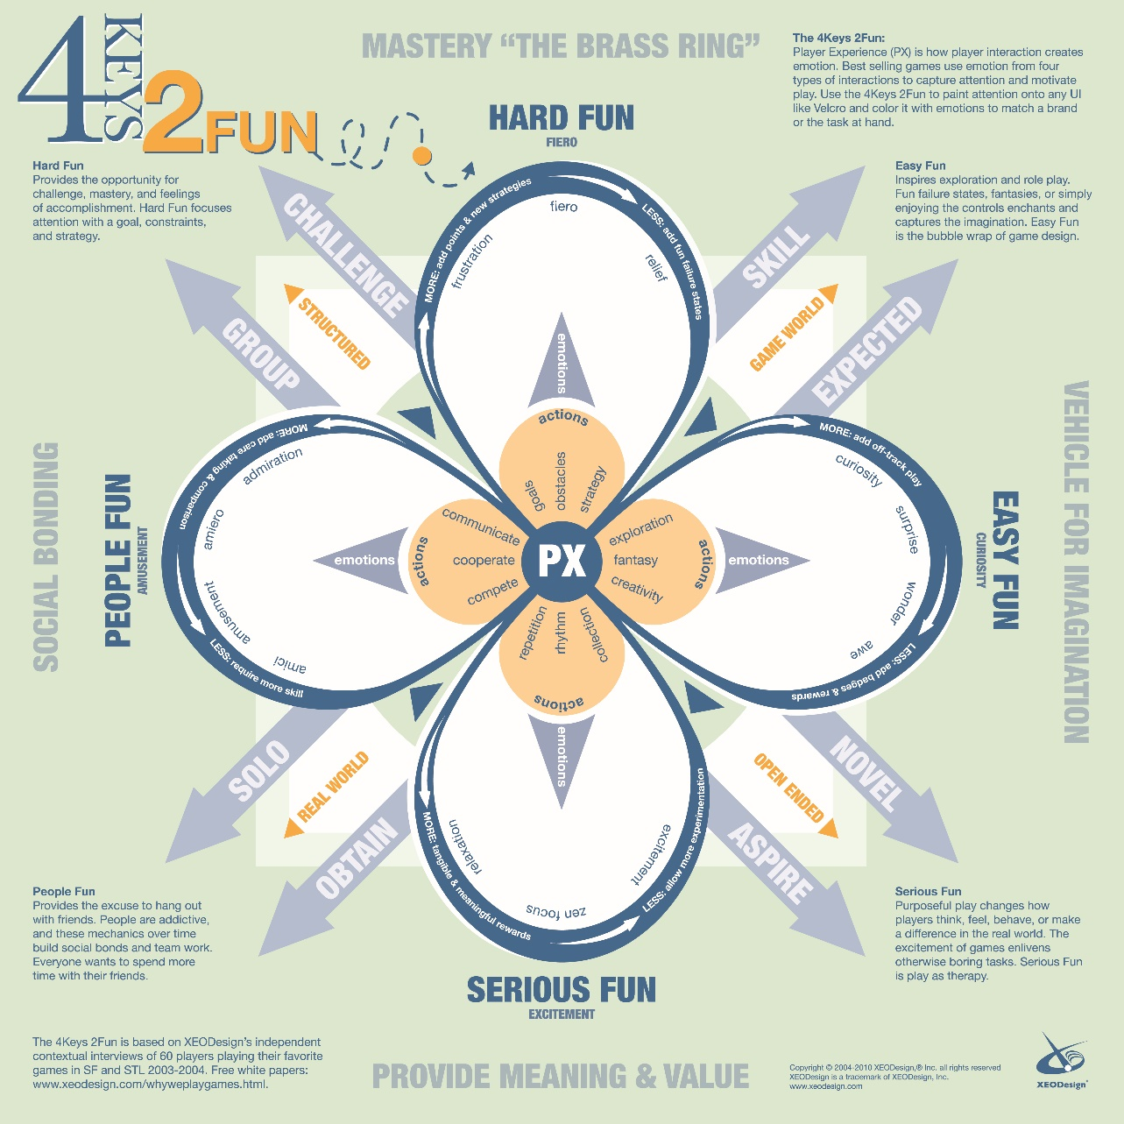Type of fun:

* Hard fun – goals, challenges, strategy, obstacles, fiero

Game loop:

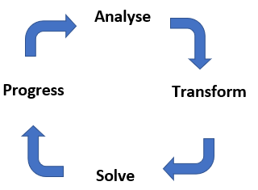

* Player analyses the environment in front of them
* Transforms into an animal depending on what is required (each animal has various skills that are useful in different scenarios)
* After solving the puzzle, the player can progress

**Puzzle Game**

* 2 player
* Cooperative
* Top down
* Fast paced
* Players have to solve puzzles within a time limit

Target Audience:

* Males and females
* Achievers – collectibles, completing challenges, progression
* Socializers – forming relationships with other players by telling stories in the game world

Types of fun:

* People fun – amusement, cooperation, communication, social bonding
* Hard fun – challenges, strategy, goals, obstacles, fiero

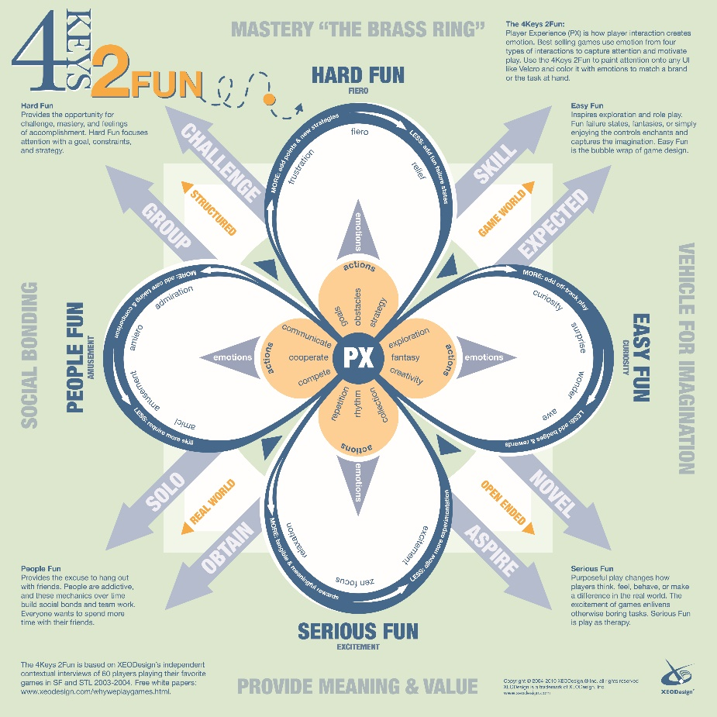Game loop: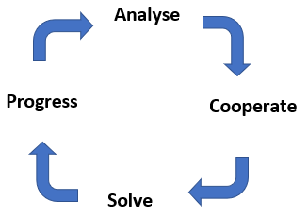

* Players analyse the puzzle in front of them
* Players both need to cooperate in order to solve the puzzle in front of them
* Once the puzzle is solved, players can progress to the next room